Ethical Hacking Task 01: Information Gathering & Reconnaissance

Part A: Target Selection
Website Name: Kristu Jayanti College Official Website
URL: https://kristujayanti.edu.in/
Reason: It is a well-known public website with modern security practices, making it useful for educational analysis of web technologies and security mechanisms.

Part B: WHOIS Lookup
Perform a WHOIS lookup using a public WHOIS lookup service.
Find and document:
- Domain Name: kristujayanti.edu.in
- Registrar: http://www.ernet.in
- Registration Date: 2012-04-20
- Expiry Date: 2035-04-20
- Name Servers
- Domain StatusL ok

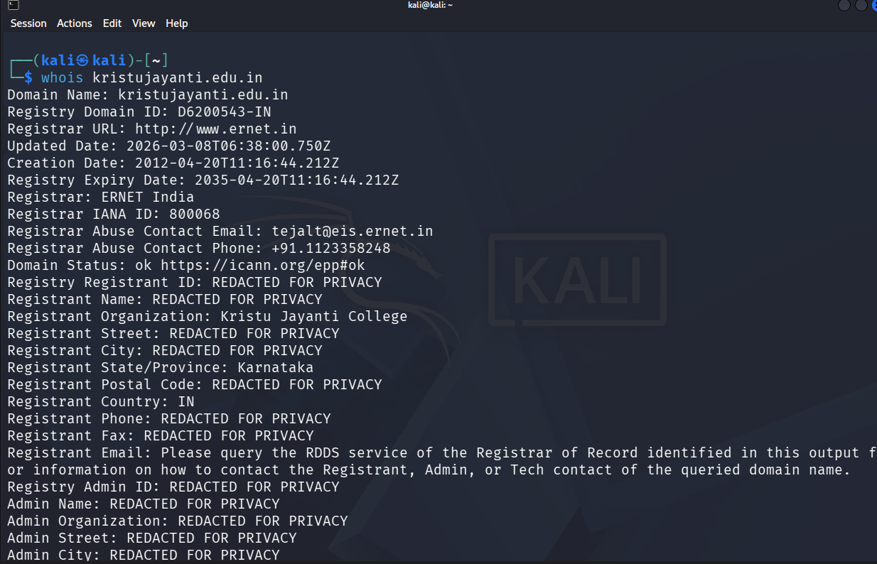
Part C: DNS Enumeration
Identify the following information:
- A Record
- MX Record
- NS Record
- TXT Record (if available)

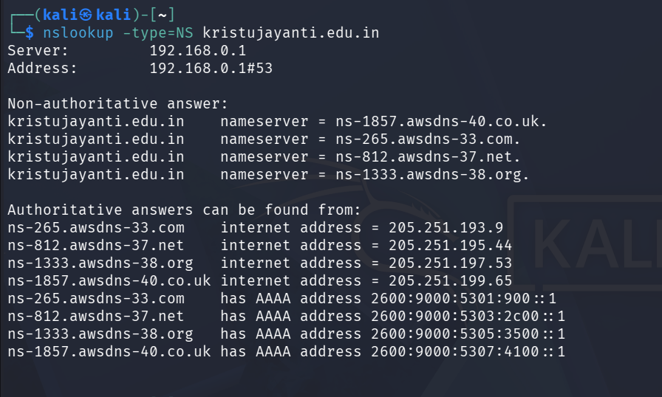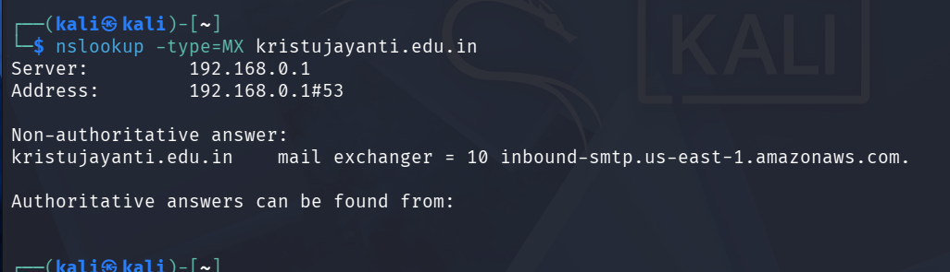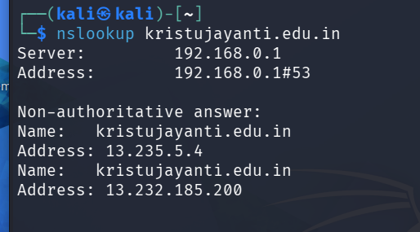
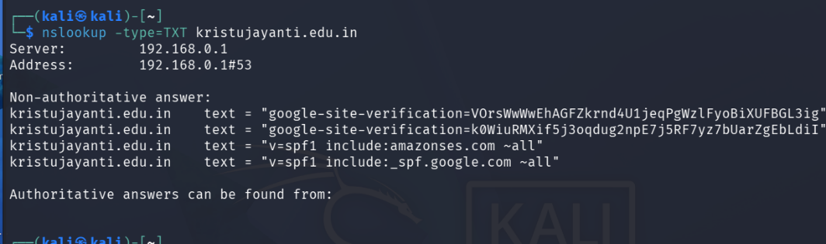
Part D: Website Technology Identification

Technology | Identified
Web Server | Apache 2.4.41
CMS | Not detected
Programming Language | Not detected
JavaScript Framework/Libraries | Google Tag Manager, Google Analytics
CDN | Not detected
Operating System | Ubuntu Linux
Summary: The website is hosted on an Apache 2.4.41 web server running Ubuntu Linux. It uses Google Tag Manager and Google Analytics for tracking and website analytics. No CMS, programming language, or CDN was identified from the scan.

Part E: HTTP Security Headers

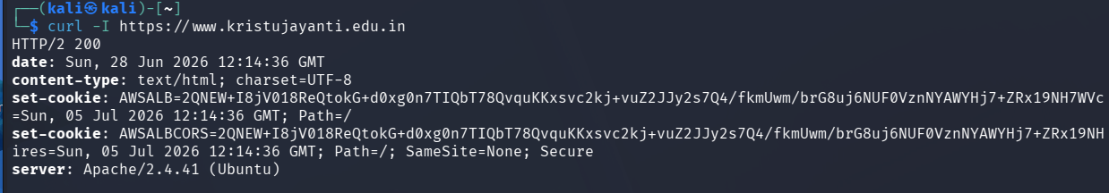

Header | Present (Yes/No) | Purpose
Content-Security-Policy (CSP) | No | Helps prevent Cross-Site Scripting (XSS) and restricts which resources can be loaded.
X-Frame-Options | No | Protects against clickjacking by preventing the site from being embedded in frames.
X-Content-Type-Options | No | Prevents browsers from MIME-type sniffing.
Strict-Transport-Security (HSTS) | No | Forces browsers to always use HTTPS for the website.
Referrer-Policy | No | Controls how much referrer information is sent with requests.

Part F: Robots.txt & Sitemap Analysis
Visit:
- https://www.kristujayanti.edu.in/robots.txt
- https://www.kristujayanti.edu.in/sitemap.xml

- Does the website have a robots.txt file?
Yes

- Does it have a sitemap?
Yes

- What information can be learned from these files?
The robots.txt file contains instructions for search engine crawlers, specifying which parts of the website can or cannot be accessed. The sitemap.xml file lists important website pages, helping search engines discover and index the site's content more efficiently.

